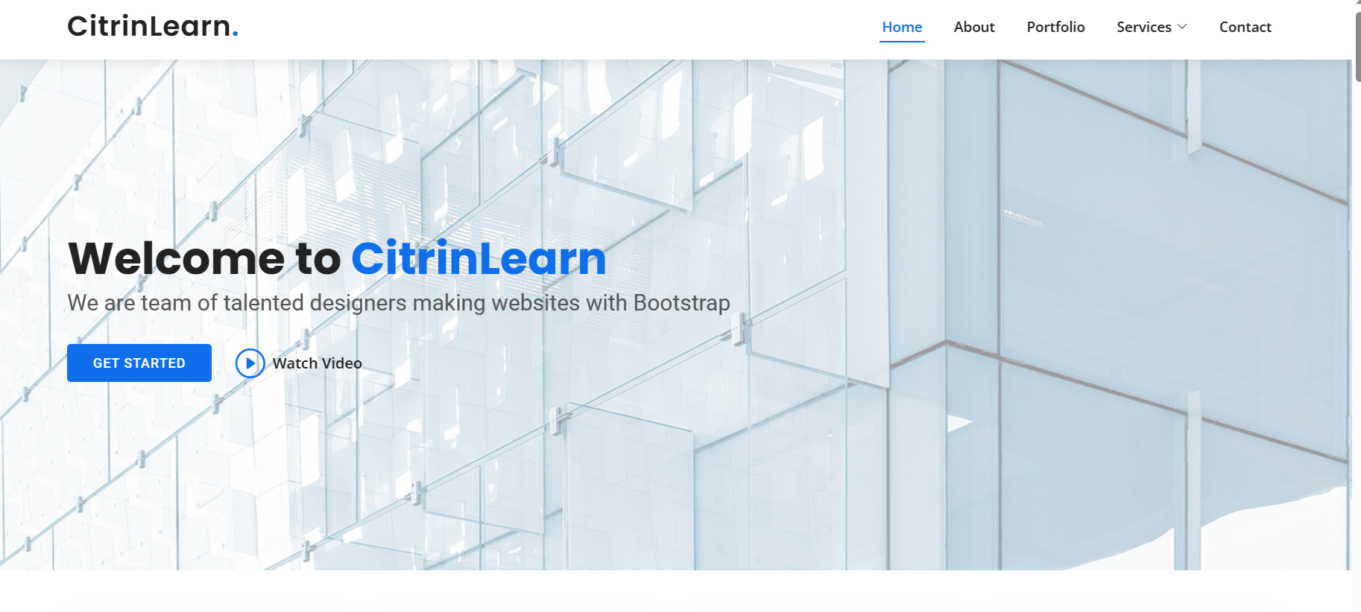

**Learning Reimagined**

We craft unique and personlised learning content that drives results

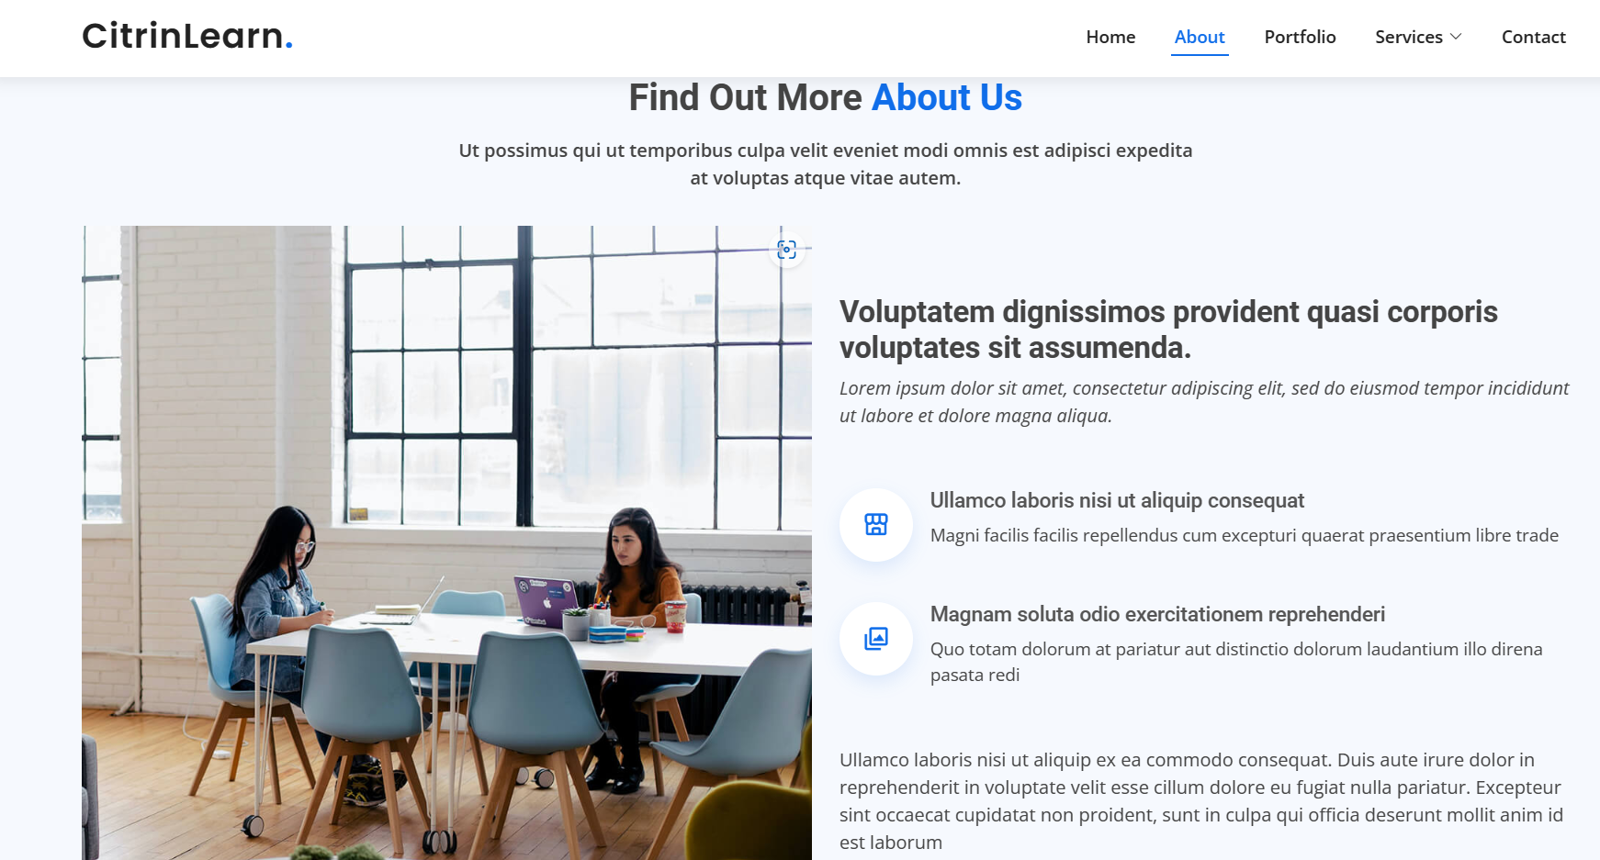

About Us

Welcome to our page! We're thrilled that you're trying to know more about us.

* **Our Team:**

We're a bunch of misfits who decided to start a company because we realized that we share the same dream.

Our team includes a Chemist, a Statistician, Biotechnologist, a Fashion designer, a Humanities Graduate

We come from all walks of life, but we share a passion for creating something new and exciting.

* **Our Mission**

At CitrinLearn we are committed to delivering exceptional value to our clients. We measure our success by the success of our clients and their employees.

Our mission is to work closely with organizations and their employees, to achieve their full potential through engaging and impactful learning experiences.

Our goal is to provide top-quality learning content that is tailored to the specific needs and goals of each organization we work with.

* **Our Services**

We understand that corporate learning can be challenging, especially in today's fast- paced and ever-changing business landscape. That's why we strive to create content that is not only informative but also interactive and fun.

Our team of experts is dedicated to staying up-to-date with the latest trends and best practices in corporate learning.

So, if you're looking for a company that takes its work seriously but doesn't take itself too seriously, you've come to the right place. We're excited to see where this adventure takes us, and we're glad to have you along for the ride.

Thanks for stopping by!