Assignment 2

Assignment: Find a colour image of a successfully lighted environment. This image should illustrate multiple pieces of light accomplishing different effects. Create list of the layers of light as discussed and identify how each piece of light corresponds to a particular layer.

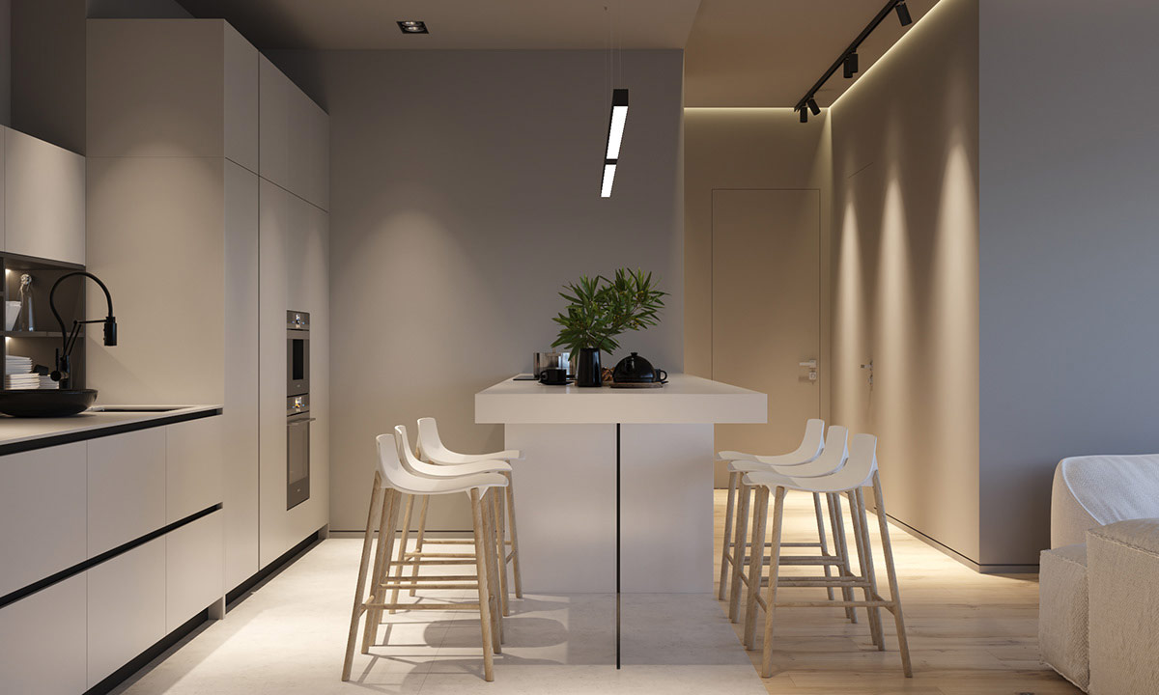

1. The kitchen counter top is with enough task light
2. Track light is provided in entrance level and wall is highlighted with this
3. In my opinion not enough light is provided in dining area .there need more light for avoiding the shadow which is occurred.