Assignment 1

Assignment: Project Case Study of Exterior lighting that has enough descriptive ingredients to form a vivid image of mood and environment in your mind and its importance.

Exterior lighting is mainly for safety ,security ,guidance and recreations. Now a days night shopping and night travelling is more ,compared with past time. So its necessary to highlight the exterior appearance rather than past .

If we design a residential or commercial building the exterior light is as important as interior light . Here I am attaching a residential view which is designed with some exterior façade lighting

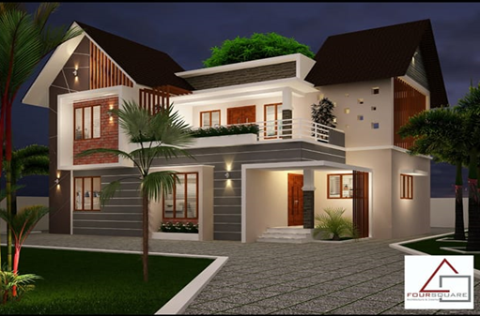

1. Some wall washers are provided for highlighting the wall texture.
2. Some general lights are provided in common area